MEDIA RELEASE/ APRIL 2020 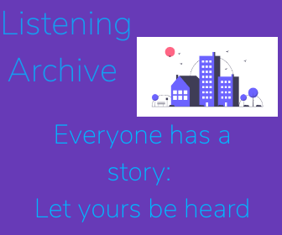

**LISTENING ARCHIVE PRODUCTIONS presents**

**A FIRST LISTEN TO A UNIQUE PODCAST THAT CHRONICLES OUR NATION’S STORY DURING OUR TIME OF MOST RECENT NEED.**

Co-created by Somerset- based Media teacher Aimee Coelho and 2020 Sixth-form leaver Charlie Kilner, each episode focuses on the stories that have been submitted to the unique Listening Archive platform during that week. The series will weave together narration and field and submitted recordings, as well as occasional interview segments.

**Listening Archive** *(* [*www.listeningarchive.com*](http://www.listeningarchive.com)*)* presents a special experience to the listener as they get to hear their own Covid19 story alongside those from across the world. Charlie and Aimee thought of the idea during a lesson at Millfield School, just before the UK temporarily closed all schools ,because of the global pandemic.

Charlie, a Computer-science, Business and Media student coded a website that meant that people could record a story directly onto it by pressing a simple record button. The audio is then collected into a secure cloud storage system, where he and Aimee look at the submitted files for that week to go into the podcast.

Charlie, 18 said: “*I am one of the 2020 Sixth-Form leavers who has been left pretty sad and a little devastated after school ended so abruptly for us. When my media teacher suggested this project for me, I was really interested in helping out, not only to use my coding experience to benefit others, but also to hear the stories of those who are probably feeling those same emotions.”*

*Media teacher Aimee said: “I’ve been wanting to develop a platform like this for a while after hearing an interview with dementia sufferers and how they wanted to tell their story. It seemed really apt to start work on it during the current times, but I very much hope it will become a useful platform to connect all kinds of communities. The interesting thing is that both Charlie and I have been working on it totally remotely and both after feeling a great degree of sadness with such a big change to our lives like many people across the world*

**About us:**

Listening Archive is podcast that brings our communities to life with sound and stories. Each podcast is worked on by a team consisting of a media student and teacher with music also provided by 2020 Sixth-Form leavers. For more information contact Aimee or Charlie at [listeningarchive@gmail.com](mailto:listeningarchive@gmail.com) or Aimee on 07933 194259.